# ELEC-240 Lab6

# Communicating over USART (RS-232 terminal) on theSTM32F429 Nucleo-144 Development Board

## 1 Introduction

In this lab you will configure the on-board USART module to communicate with the RS-232

serial port on the PC. Refer to Table 1 for information.

### 1.1 Learning Outcomes

* By the end of this lab exercise you should be able to:

1. Demonstrate an understanding of USART functionality and timing
2. Produce code to enable the on-board USART module and communicate over RS-232

There are various programs that can be used to interface the PC terminal. ***PUTTY*** is

used on the lab machines.

### Task 1

The example code provided on the DLE repeatedly sends the letter `A' to the terminal.

1. Open ***PuTTY***
2. Select ***Serial*** as the connection type, ***COM1*** as the serial line and ***9600*** as the baudrate, 8 Data bits, No Parity and 1 stop bit, No Flow Control. (Shown in Figure 1)

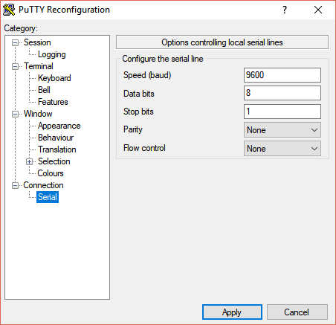

Figure 1. PuTTY settings

**NOTE:** Make sure the coms port selected in ***PuTTY*** is correct.

Go to Windows ***Device Manager*** looks in ***Ports(COM & LPT)*** and see which one is ***STLink Virtual COM Port***. In this example COM4 should be used instead of COM1

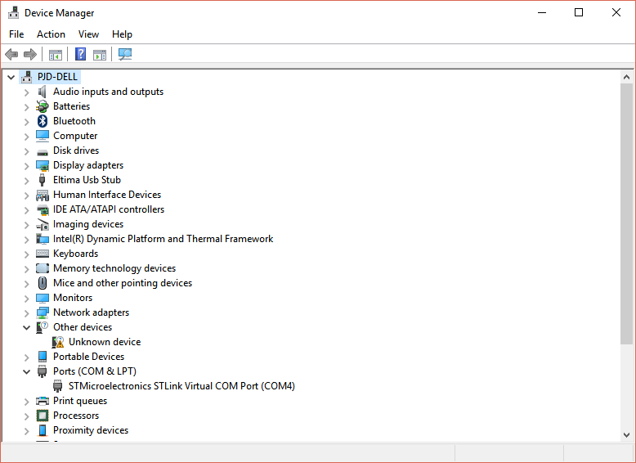

Figure 2. Device Manager showing STLink COM Port … (COM4)

1. Build and download the code to the development board then use the oscilloscope to probe the TX/RX pins on the board to verify the correct signals are being sent.
2. Sketch the output you observe.

NOTE: You will see the transmission **inverted** and at **0 -3 volts** format whereas Figure 3 shows the correct RS-232 standard output from a Max-232 line-driver.



Figure 3: RS-232 timing diagram for the ASCII character `A'

(Note that the waveform shown has been level shifted and inverted using a line driver)

### Task 2

Measure the time of the shortest pulse and confirm that it corresponds to the required baudrate. The example code uses 9600bps (Bits per Second) therefore each bit period is given by

Tbit = 1/Baudrate

and should be **104μs** at 9600bps.

### Task 3

Modify the program to write a string to the PC terminal (***PuTTY***) such as “Hello World".

### Task 4

Incorporate USART read functionality into the program using the ***RXNE*** bit in the ***USART***

***Status Register*** to detect when a char has been received.

### Task 5

Modify the read functionality to include the use of interrupts. An interrupt can be generated

when the ***RXNE*** bit is asserted. You can refer to Lab3 for enabling interrupts.

### Task 6

Redirect the ***printf*** function from the standard library to send characters to the PC terminal over USART. Hint: Refer to code in USART lecture notes.

### Task 7

Modify the program to include a Hexadecimal to Ascii function that displays a count on ***PuTTY***

### Task 8

Uncomment the code to Run the processor at 180Mhz … this will stop the code running correctly because the inaccurate baudrate setting in the **init_USART()** function. Enter the correct baudrate formulae to fix the problem.

## 2 Support Documentation

|  |  |
| --- | --- |
| Document Name | Contained Information |
| [UM1974 User manual](https://www.st.com/content/ccc/resource/technical/document/user_manual/group0/26/49/90/2e/33/0d/4a/da/DM00244518/files/DM00244518.pdf/jcr:content/translations/en.DM00244518.pdf) | * Pin identification and the supported special functions * Circuit schematics * Jumper and component identification * Header pinouts |
| [RM0090 Reference manual](https://www.st.com/content/ccc/resource/technical/document/reference_manual/3d/6d/5a/66/b4/99/40/d4/DM00031020.pdf/files/DM00031020.pdf/jcr:content/translations/en.DM00031020.pdf) | * MCU memory and peripherals architecture * Peripheral control registers, addresses and bit-fields |

Table 1: Table of relevant support documentation for Nucleo-144 development boards

(The document names are hyperlinks, please click on them to access the documents)